

**Web Application Transaction (WAT) Monitor**

**Service Package Description   
(Part Number PCP-WATM-SPD)**

WAT Monitor records, replays and produces Web transaction response time reports for any web site as a user would experience it at different times of the day.

By following a typical user profile and actions on a web site, WAT Recorder will automatically produce an action script. After recording is completed, WAT Player will replay the same set of actions on the same site at specified time intervals. The WAT Monitor will provide extensive analytical details about the site performance throughout the day, week, month etc., with no requirements for complex script writing!

WAT is an extremely critical tool for businesses of all sizes with a strategic online web presence.

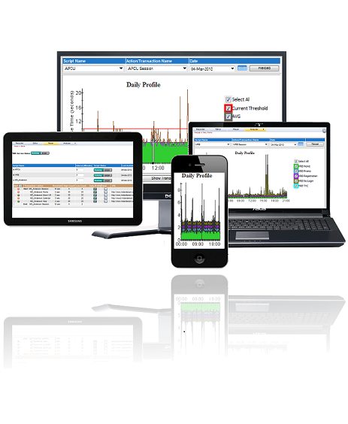



Internet/  
Intranet

*Interactive Web User Business Data Center*

**Why would you want to use this technology?** With this offering any institution providing web-based customer service such as Banks, Stock Exchanges, Online Retailers, or Customer Support sites etc., can monitor both their internet and intranet web applications’ end-to-end response times. Web site performance or availability issues automatically trigger intelligent notification for detailed analysis.

In addition to offering this technology as an off-the-shelf software package, PerfCap offers it as a subscription based service. Under this service PerfCap’s Servers will periodically monitor a predefined set of your web site pages and provide their response time and availability reports.

**Service Package Description**

**Silver Package: $50.00/month**

* Monitor up to three (3) web pages of your choice at 15 min (or more) interval
* Provide monthly web-site responsiveness reports
  + For each web page, graph of daily min, max and average response time
  + Full day response time graph of two days with maximum session response times
  + Daily response time SLA checkerboard (thresholds TBD)
  + Monthly response time distribution chart
* Provide monthly web-site up-time report
  + For each web page daily % up-time
  + Daily up-time SLA checkerboard (thresholds TBD)

**Gold Package: $250/month**

* Monitor up to five (5) web pages of your choice at 5 min (or more) interval
* Provide monthly web-site responsiveness reports
  + For each web page, graph of daily min, max and average response time
  + Full day response time graph of five days with maximum session response times
  + Full day response time breakdown graph of five days with maximum session response times for each web page
  + Daily response time SLA checkerboard (thresholds TBD)
  + Monthly response time distribution chart
  + In depth analysis of monthly response time data
* Provide monthly web-site up-time report
  + For each web page daily % up-time
  + Daily up-time SLA checkerboard (thresholds TBD)
* Real-Time alerts

**Platinum Package: $750/month**

* Monitor up to five (5) web pages of your choice at 5 min (or more) interval from three locations
* Provide monthly web-site responsiveness reports
  + For each web page, graph of daily min, max and average response time
  + Full day response time graph of five days with maximum session response times
  + Full day response time breakdown graph of five days with maximum session response times for each web page
  + Daily response time SLA checkerboard (thresholds TBD)
  + Monthly response time distribution chart
  + In depth analysis of monthly response time data
* Provide monthly web-site up-time report
  + For each web page daily % up-time
  + Daily up-time SLA checkerboard (thresholds TBD)
* Real-Time alerts
* An account on our web server to interactively monitor (24x7) web site performance